TRANSFORMATIONS OF FUNCTIONS
REFLECTIONS OF GRAPHS OF FUNCTIONS

Given graphs: | 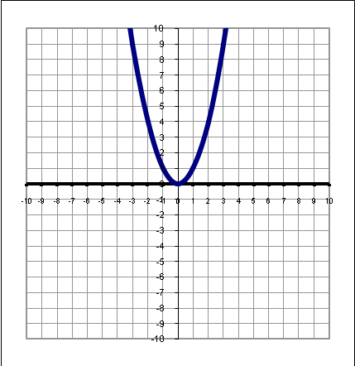 | 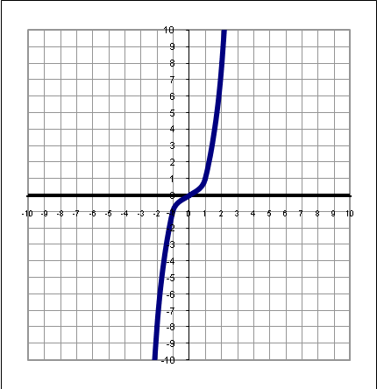 | 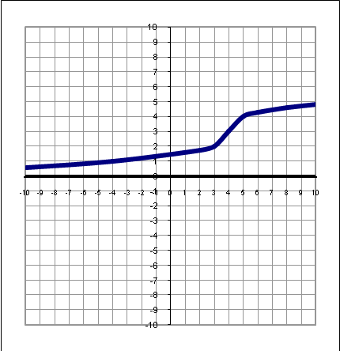
Reflections across the x axis (vertical flip)  Given the graph of y=f(x), the graph of y=–f(x) is exactly the same size and shape, but is the mirror image across the x-axis. | 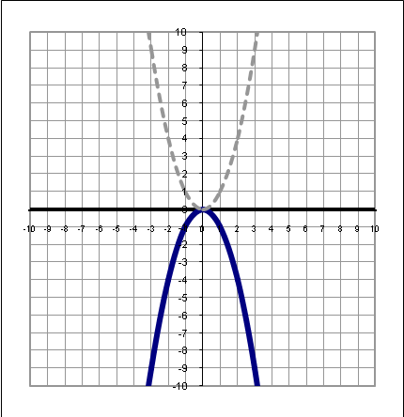 | 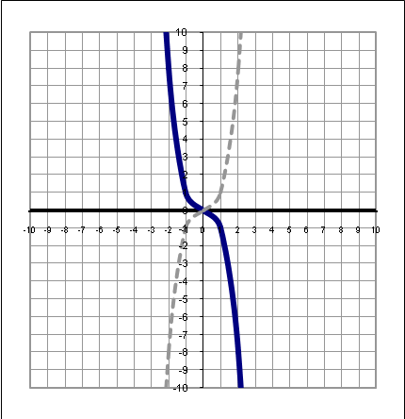 | 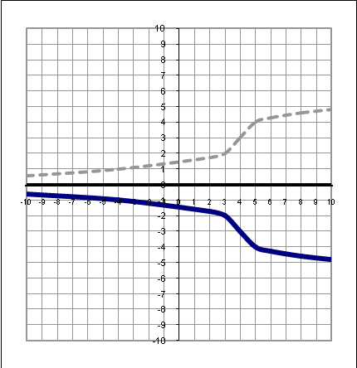
Reflections across the y axis (horizontal flip)  Given the graph of y=f(x), the graph of y=f(–x) is exactly the same size and shape, but is the mirror image across the y-axis. | 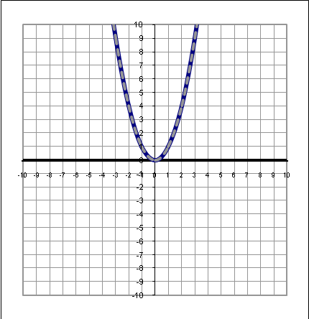 |  | 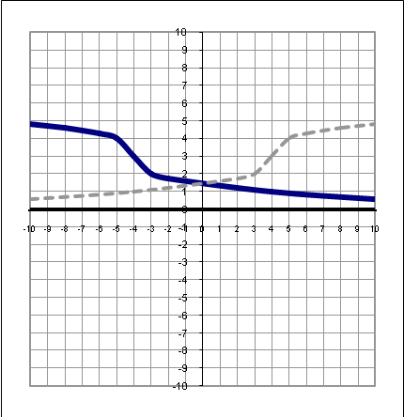
VERTICAL SCALING (STRETCHING/SHRINKING) OF THE GRAPH OF A FUNCTION

Given graphs:

Vertical Stretching  Given the graph of y=f(x), the graph of y= a•f(x), a>1, has vertical values which are a times the vertical values of y=f(x) for the corresponding horizontal values. The graph is now “taller.”  The following graphs have been vertically stretched by a factor of 2. (Twice as tall) y=2f(x) | 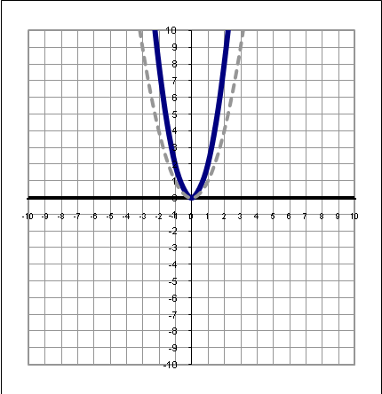 | 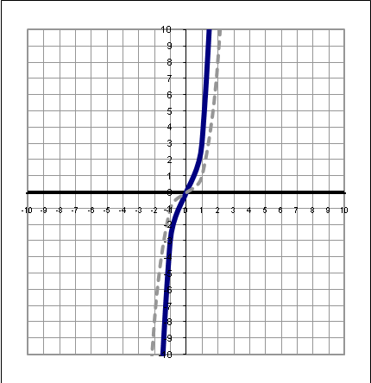 | 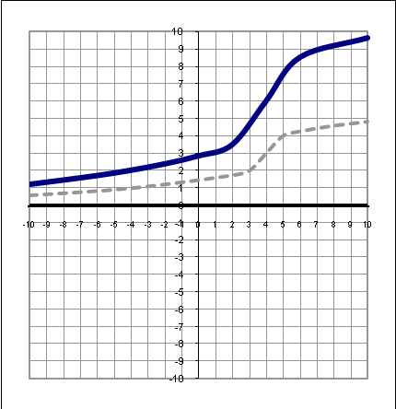
Vertical Shrinking  Given the graph of y=f(x), the graph of y=a•f(x), 0<a<1, has vertical values which are a times the vertical values of y=f(x) for the corresponding horizontal values. The graph is now “shorter.”  The following graphs have been vertically shrunk by a factor of 2. (Half as tall) y=$\frac{1}{2}$f(x) | 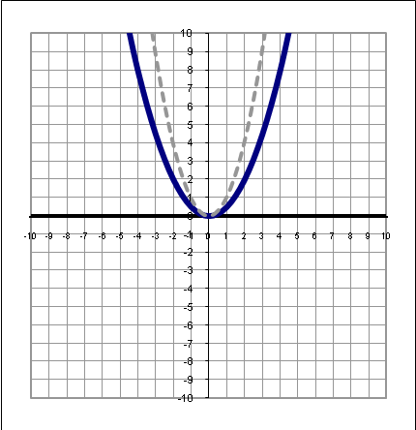 | 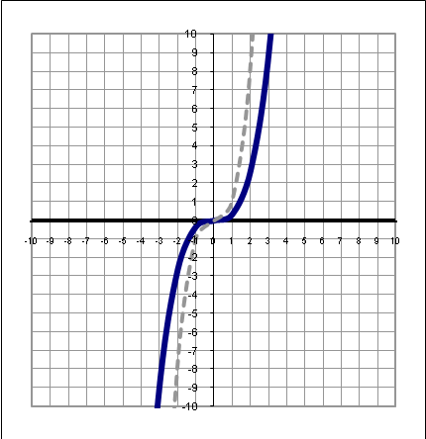 | 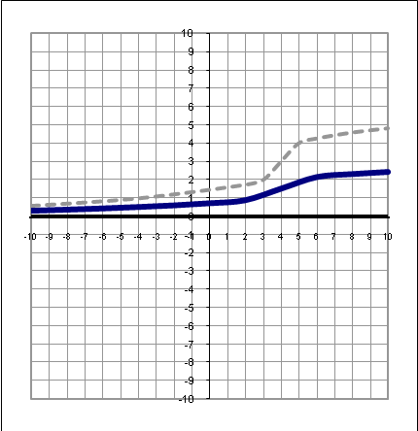
HORIZONTAL SCALING (STRETCHING/SHRINKING) OF THE GRAPH OF A FUNCTION

Given graphs:

Horizontal Stretching  Given the graph of y=f(x), the graph of y=f(b •x), 0<b<1, has horizontal values which are 1/b times the horizontal values of y=f(x) for the corresponding vertical values. The graph is now “wider.”  The following graphs have been horizontally stretched by a factor of 2. (Twice as wide) y=f($\frac{1}{2}$x) | 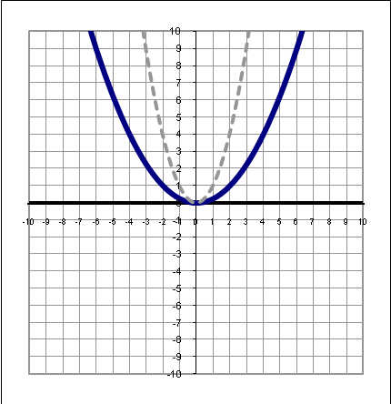 | 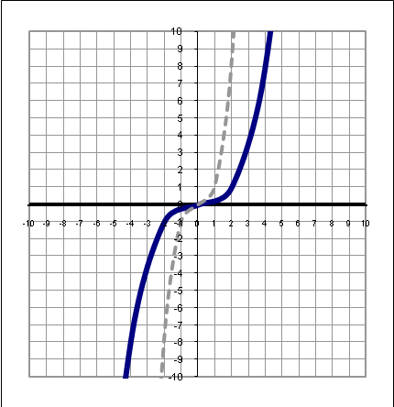 | 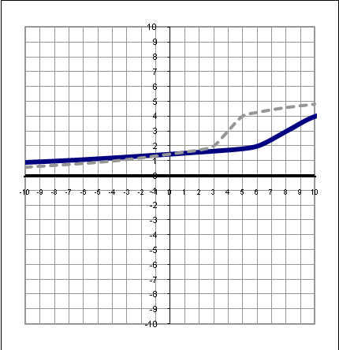
Horizontal Shrinking  Given the graph of y=f(x), the graph of y=f(b•x), b>1, has horizontal values which are 1/b times the horizontal values of y=f(x) for the corresponding vertical values. The graph is now “skinnier.”  The following graphs have been horizontally shrunk by a factor of 2. (Half as wide) y=f(2x) | 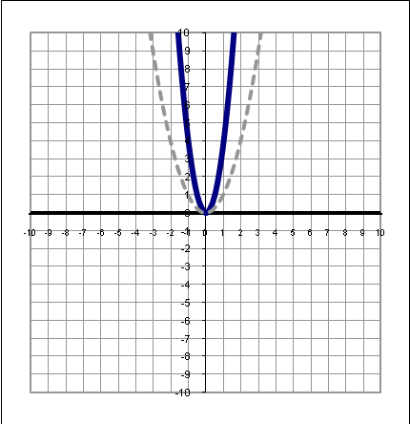 | 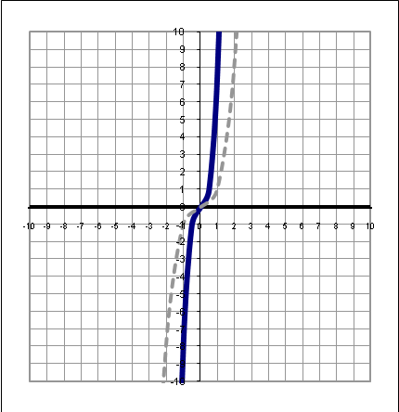 | 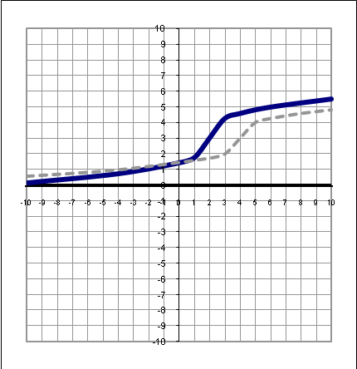
VERTICAL TRANSLATIONS (SHIFTS) OF GRAPHS OF FUNCTIONS

Given graphs:

Vertical Shift Up  Given the graph of y=f(x), the graph of y=f(x)+d, d >0,  is exactly the same size and shape as y=f(x), but moved upward d units.  The following graphs have been shifted up 2 units. y=f(x)+2 | 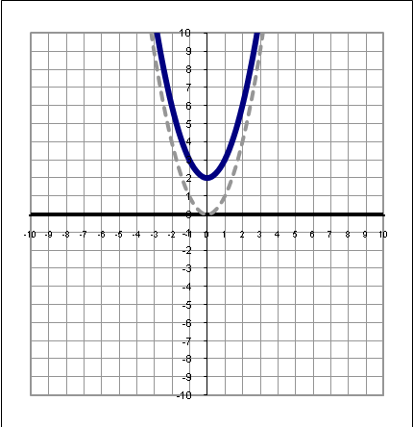 | 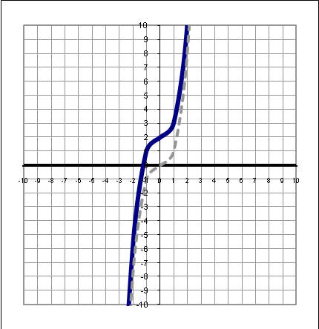 | 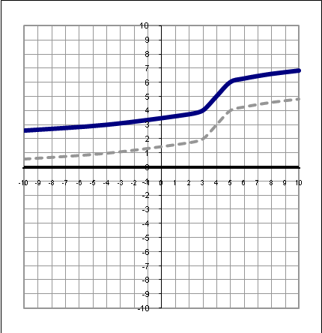
Vertical Shift Down  Given the graph of y=f(x), the graph of y=f(x) –d, d >0,  is exactly the same size and shape as y=f(x), but moved downward d units.  The following graphs have been shifted down 2 units. y=f(x) –2 | 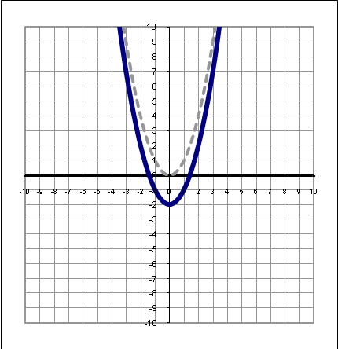 | 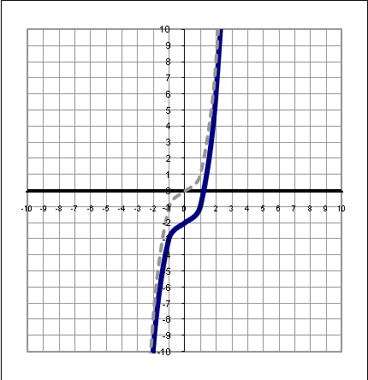 | 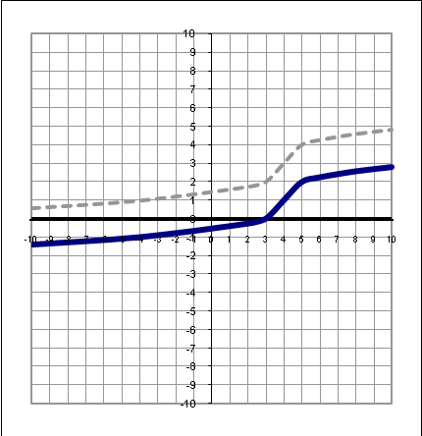
HORIZONTAL TRANSLATIONS (SHIFTS) OF GRAPHS OF FUNCTIONS

Given graphs:

Horizontal Shift Left  Given the graph of y=f(x), the graph of y=f(x+c), c >0,  is exactly the same size and shape as y=f(x), but moved  left c units.  The following graphs have been shifted left 2 units. y=f(x+2) | 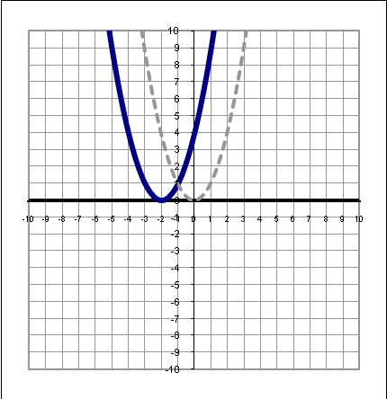 | 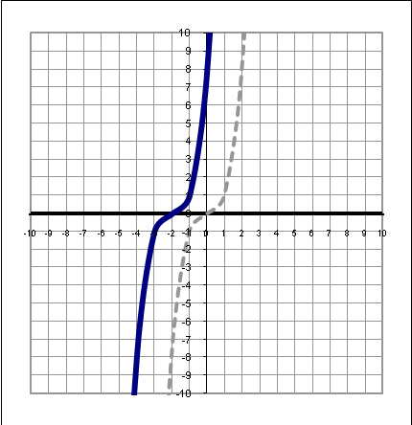 | 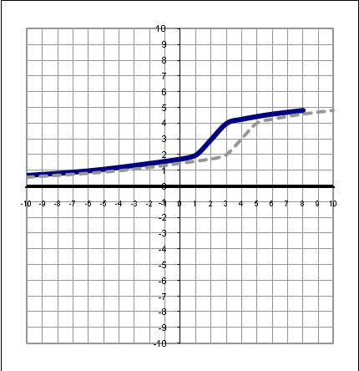
Horizontal Shift Right  Given the graph of y=f(x), the graph of y=f(x– c), c >0,  is exactly the same size and shape as y=f(x), but moved  right c units.  The following graphs have been shifted right 2 units. y=f(x–2) | 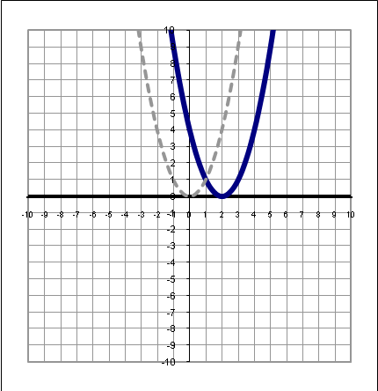 | 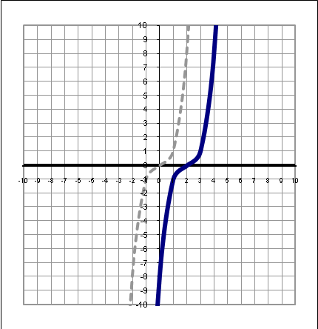 | 